Data Service Center Ed-Fi Security
Listed below are the claimsets assigned to DSC, including resource claims and permissions. Updated 10/22/2025
Claimset | ResourceClaims | Permissions
504Program | localEducationAgency | Read, ReadChanges
504Program | person | Read, ReadChanges
504Program | program | Read, ReadChanges
504Program | school | Read, ReadChanges
504Program | student | Read, ReadChanges
504Program | student504ProgramAssociation | Read, ReadChanges
504Program | systemDescriptors | Read, ReadChanges
504Program | types | Read, ReadChanges
AssessmentScores | assessment | Read, ReadChanges
AssessmentScores | assessmentItem | Read, ReadChanges
AssessmentScores | localEducationAgency | Read, ReadChanges
AssessmentScores | managedDescriptors | Read, ReadChanges
AssessmentScores | objectiveAssessment | Read, ReadChanges
AssessmentScores | person | Read, ReadChanges
AssessmentScores | school | Read, ReadChanges
AssessmentScores | student | Read, ReadChanges
AssessmentScores | studentAssessment | Read, ReadChanges
AssessmentScores | studentAssessmentEducationOrganizationAssociation | Read, ReadChanges
AssessmentScores | studentEducationOrganizationAssociation | Read, ReadChanges
AssessmentScores | systemDescriptors | Read, ReadChanges
AssessmentScores | types | Read, ReadChanges
Attendance | localEducationAgency | Read, ReadChanges
Attendance | person | Read, ReadChanges
Attendance | school | Read, ReadChanges
Attendance | section | Read, ReadChanges
Attendance | student | Read, ReadChanges
Attendance | studentSchoolAttendanceEvent | Read, ReadChanges
Attendance | studentSectionAssociation | Read, ReadChanges
Attendance | studentSectionAttendanceEvent | Read, ReadChanges
Attendance | systemDescriptors | Read, ReadChanges
Attendance | types | Read, ReadChanges
Discipline | allegedBullyingVictim | Read, ReadChanges
Discipline | disciplineAction | Read, ReadChanges
Discipline | disciplineIncident | Read, ReadChanges
Discipline | localEducationAgency | Read, ReadChanges
Discipline | person | Read, ReadChanges
Discipline | restraintEvent | Read, ReadChanges
Discipline | restraintSeclusion | Read, ReadChanges
Discipline | school | Read, ReadChanges
Discipline | staff | Read, ReadChanges
Discipline | staffDisciplineIncidentAssociation | Read, ReadChanges
Discipline | student | Read, ReadChanges
Discipline | studentDisciplineIncidentAssociation | Read, ReadChanges
Discipline | studentDisciplineIncidentBehaviorAssociation | Read, ReadChanges
Discipline | studentDisciplineIncidentNonOffenderAssociation | Read, ReadChanges
Discipline | systemDescriptors | Read, ReadChanges
Discipline | types | Read, ReadChanges
EnglishLearner | localEducationAgency | Read, ReadChanges
EnglishLearner | person | Read, ReadChanges
EnglishLearner | program | Read, ReadChanges
EnglishLearner | school | Read, ReadChanges
EnglishLearner | student | Read, ReadChanges
EnglishLearner | studentLanguageInstructionProgramAssociation | Read, ReadChanges
EnglishLearner | systemDescriptors | Read, ReadChanges
EnglishLearner | types | Read, ReadChanges
Graduation | graduationPlan | Read, ReadChanges
Graduation | localEducationAgency | Read, ReadChanges
Graduation | person | Read, ReadChanges
Graduation | postSecondaryDetail | Read, ReadChanges
Graduation | postSecondaryEvent | Read, ReadChanges
Graduation | postSecondaryInstitution | Read, ReadChanges
Graduation | school | Read, ReadChanges
Graduation | student | Read, ReadChanges
Graduation | studentAcademicRecord | Read, ReadChanges
Graduation | studentSchoolAssociation | Read, ReadChanges
Graduation | systemDescriptors | Read, ReadChanges
Graduation | types | Read, ReadChanges
HealthRecords | localEducationAgency | Read, ReadChanges
HealthRecords | medicalAlert | Read, ReadChanges
HealthRecords | medicalOfficeVisit | Read, ReadChanges
HealthRecords | medicalReferralFollowUp | Read, ReadChanges
HealthRecords | medicalScreening | Read, ReadChanges
HealthRecords | medicationBox | Read, ReadChanges
HealthRecords | person | Read, ReadChanges
HealthRecords | personImmunization | Read, ReadChanges
HealthRecords | personMedicalAlert | Read, ReadChanges
HealthRecords | school | Read, ReadChanges
HealthRecords | student | Read, ReadChanges
HealthRecords | systemDescriptors | Read, ReadChanges
HealthRecords | types | Read, ReadChanges
SpecialEducationProgram | localEducationAgency | Read, ReadChanges
SpecialEducationProgram | person | Read, ReadChanges
SpecialEducationProgram | program | Read, ReadChanges
SpecialEducationProgram | school | Read, ReadChanges
SpecialEducationProgram | student | Read, ReadChanges
SpecialEducationProgram | studentSpecialEducationProgramAssociation | Read, ReadChanges
SpecialEducationProgram | systemDescriptors | Read, ReadChanges
SpecialEducationProgram | types | Read, ReadChanges
Staff | localEducationAgency | Read, ReadChanges
Staff | person | Read, ReadChanges
Staff | program | Read, ReadChanges
Staff | school | Read, ReadChanges
Staff | staff | Read, ReadChanges
Staff | staffCohortAssociation | Read, ReadChanges
Staff | staffEducationOrganizationAssignmentAssociation | Read, ReadChanges
Staff | staffEducationOrganizationContactAssociation | Read, ReadChanges
Staff | staffProgramAssociation | Read, ReadChanges
Staff | staffSchoolAssociation | Read, ReadChanges
Staff | staffSectionAssociation | Read, ReadChanges
Staff | systemDescriptors | Read, ReadChanges
Staff | types | Read, ReadChanges
StudentCohort | cohort | Read, ReadChanges
StudentCohort | localEducationAgency | Read, ReadChanges
StudentCohort | person | Read, ReadChanges
StudentCohort | school | Read, ReadChanges
StudentCohort | student | Read, ReadChanges
StudentCohort | studentCohortAssociation | Read, ReadChanges
StudentCohort | studentEducationOrganizationAssociation | Read, ReadChanges
StudentCohort | systemDescriptors | Read, ReadChanges
StudentCohort | types | Read, ReadChanges
StudentEnrollment | calendar | Read, ReadChanges
StudentEnrollment | calendarDate | Read, ReadChanges
StudentEnrollment | grade | Read
StudentEnrollment | graduationPlan | Read, ReadChanges
StudentEnrollment | localEducationAgency | Read, ReadChanges
StudentEnrollment | person | Read, ReadChanges
StudentEnrollment | school | Read, ReadChanges
StudentEnrollment | student | Read, ReadChanges
StudentEnrollment | studentEducationOrganizationResponsibilityAssociation | Read, ReadChanges
StudentEnrollment | studentSchoolAssociation | Read, ReadChanges
StudentEnrollment | systemDescriptors | Read, ReadChanges
StudentEnrollment | types | Read, ReadChanges
StudentInformation | localEducationAgency | Read, ReadChanges
StudentInformation | parent | Read, ReadChanges
StudentInformation | person | Read, ReadChanges
StudentInformation | school | Read, ReadChanges
StudentInformation | student | Read, ReadChanges
StudentInformation | studentEducationOrganizationAssociation | Read, ReadChanges
StudentInformation | studentParentAssociation | Read, ReadChanges
StudentInformation | systemDescriptors | Read, ReadChanges
StudentInformation | types | Read, ReadChanges
TeachingNLearning | bellSchedule | Read, ReadChanges
TeachingNLearning | calendar | Read, ReadChanges
TeachingNLearning | calendarDate | Read, ReadChanges
TeachingNLearning | cIPCourse | Read, ReadChanges
TeachingNLearning | classPeriod | Read, ReadChanges
TeachingNLearning | course | Read, ReadChanges
TeachingNLearning | courseOffering | Read, ReadChanges
TeachingNLearning | grade | Read, ReadChanges
TeachingNLearning | gradebookEntry | Read, ReadChanges
TeachingNLearning | gradingPeriod | Read, ReadChanges
TeachingNLearning | localEducationAgency | Read, ReadChanges
TeachingNLearning | location | Read, ReadChanges
TeachingNLearning | person | Read, ReadChanges
TeachingNLearning | school | Read, ReadChanges
TeachingNLearning | section | Read, ReadChanges
TeachingNLearning | session | Read, ReadChanges
TeachingNLearning | student | Read, ReadChanges
TeachingNLearning | studentGradebookEntry | Read, ReadChanges
TeachingNLearning | studentSchoolAssociation | Read, ReadChanges
TeachingNLearning | studentSectionAssociation | Read, ReadChanges
TeachingNLearning | systemDescriptors | Read, ReadChanges
TeachingNLearning | types | Read, ReadChanges

StudWe have been discussing how best to secure Ed-Fi data for Data Service Center use and are thinking the various categories on the data sharing agreement should dictate permissions. If we set up a security profile (claimset) for each domain/category then we can grant or revoke categories on a per district basis. This will require separate key/secrets for each area of data, but this is unavoidable.
I am going through the categories that a district may check off and comparing them to the Ed-Fi data domains. They do not match exactly, leading the questions how best to map them and whether the categories can be changed?
These are the Data Sharing Agreement Categories:
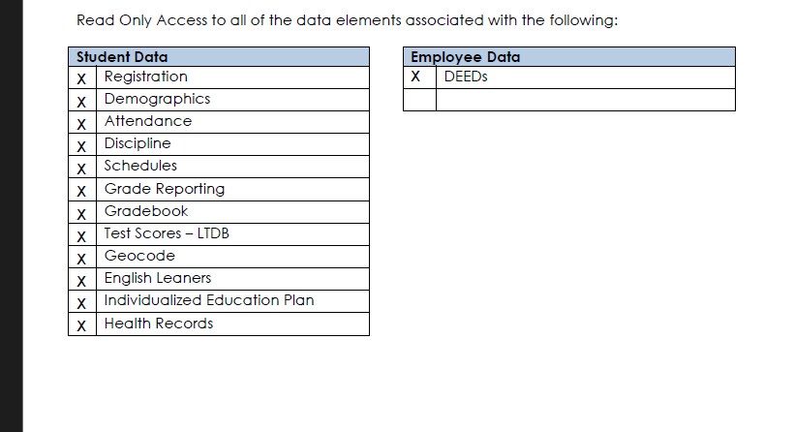

These are the Ed-Fi Domains, as of the most recent data standard (5.0):
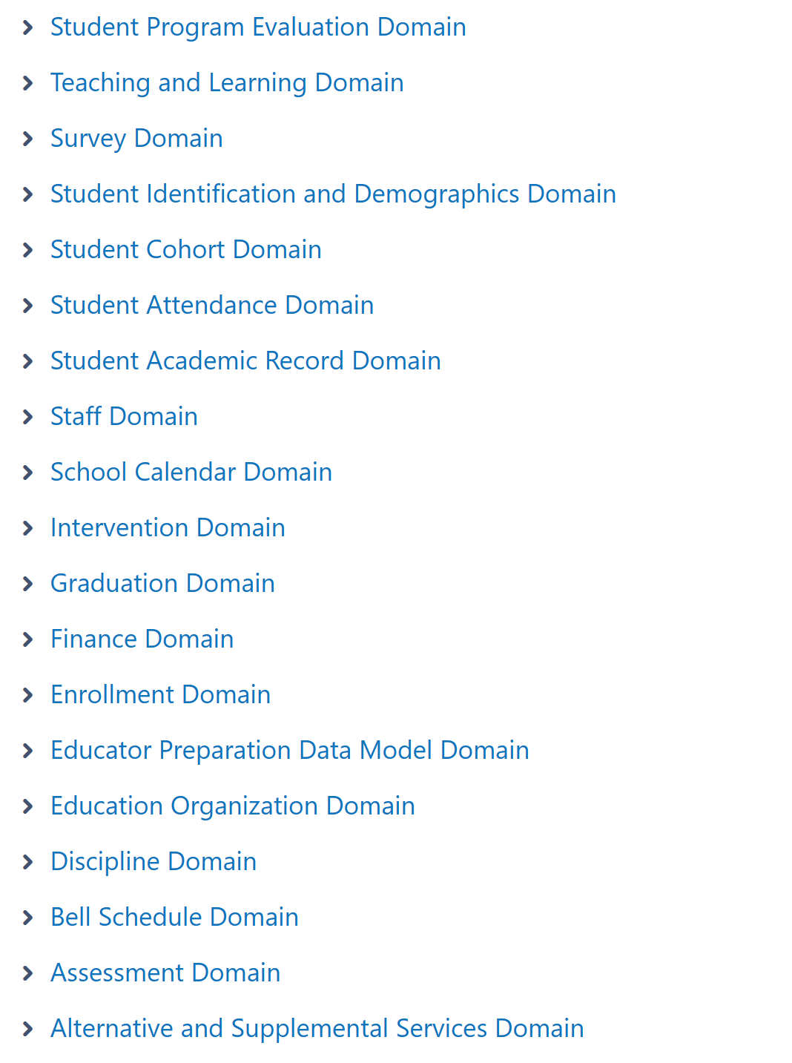
Here are some possible mappings of the Ed-Fi Domains to the Data Sharing Categories:
Ed-Fi Domain | Data Sharing Area | Notes
Teaching and Learning | Registration  Schedules  Grade Reporting
Students & Demographics | Demographics
Student Cohort | Perhaps wrap into Demographics | Student Activities
Student Attendance | Attendance
Student Academic Report | Grade Reporting
Education Organization |  | Public
Discipline | Discipline
Assessment
Alternate and Supplemental Services | English Learners  Individualized Education Plan | This is all the program associations:504, Special Ed, Language Instruction, Early Childhood, Leaning Locations and 21rst Century
{Medical} (extension) | Health Records

Questions:
- Do we need to break out Registration, Schedules and Grades or could we make Teaching and Learning be the Data Sharing Category.
- I suggest wrap Student Cohort into Students & demographics
- Education Organizations will be available to anyone with the key/secret
- We need to figure out if DSC gets access to current Ed-Fi assessments
- The Alternate and Supplemental Services incorporates all the programs, but not all of them seem easily mapped to the DSC groupings.
  - I think we should either make this one Data Sharing Category including all the programs or break them out individually.

One additional item- certain permissions are necessary in order to allow the DSC to perform their state contracts (Unit Count, Choice..). Would it be sufficient to establish the domains or categories (whatever the final list is) are necessary for the state contracts and grant permission on those by default? What would we do if a district denies enrollment information, as not having it would make Unit Count impossible?

Revised 11/8:
Which subject area for state applications:
TBD
Proposed Ed-Fi Data Areas for Securing (individual DSC claimsets):
- Teaching & Learning (Registration, Scheduling & Grades) or break them out
- Student Demographics and Cohorts
- Staff
- Attendance
- Discipline
- 504 Program Participation
- Special Education Program Participation
- English Learners
- Early Childhood
- Learning Locations
- 21rst Century
- Health Records
- Assessments (lower priority- figure out making this read only across namespaces; confirm with DCD)
Ed-Fi Allowed Access with Authentication:
Descriptors
Education Organization

Non Ed-Fi sources on the current check list:
IEP
Geocodes
Deeds
Gradebook
Assessments

Units of Analysis:
- Figuring out working list of claimsets and list of items that will be in the DSA.
- Do all but Assessment claimsets and test
- Verify descriptors/edorgs- any of the claimsets allow these to read without further validation.
- Go through data from eSchool mapping (all we can do is assume we’ll get the current data) and the Ed-Fi domains and establish the endpoints that will be in each claimset.
- Research what endpoint should go with each
- Construct claimset code in DEV and test scripts (positive and some negative).
As I understand, high priority, above warehouse work. Can you take this away and come up with a proposed schedule, say mid-week, then set up check-ins? I feel like we should be able to accomplish this in November, but is that too optimistic?

Ed-Fi Domains and its Endpoints (final):
Student Demographics **
StudentDemographicReader claimset
- Students
- StudentEducationOrganizationAssociations
- Persons
- Parents
- StudentParentAssociations
Enrollment: **
- StudentSchoolAssociations
- StudentEducationAgencyRespoonsibilityAssociations
- GraduationPlan
- Calendar
- CalendarDate
Teaching & Learning: **
- Sessions
- Sections
- Classperiods
- Locations
- Courses
- CourseOfferings
- StudentSectionAssociation
- Grade
- CIPCourse
Staff:
- Staffs
- Persons
- staffSchoolAssociations
- StaffLeaves
- StaffAbsenceEvents
- StaffEducationOrganizationContactAssociation
- StaffEducationOrganizationAssignmentAssociations--?
- StaffEducationOrganizationEmploymentAssociations--?
- Credential
- StaffProgramAssociations--?
- StaffSectionAssociations
- StaffCohortAssociations—Cohorts?
Attendance:
- Students
- Sections
- StudentSectionAssciations
- StudentSectionAttendanceEvents
- StudentSchoolAttendanceEvents
Discipline
- Student
- Staff
- DisciplineIncidents
- DisciplineActions
- StudentDisciplineIncidentAssociations
- StaffDisciplineIncidentAssociations
- StudentDisciplineIncidentBehaviorAssociations
- StudentDisciplineIncidentNonOffenderAssociations
- Restraints
504 Program Participation
- Students
- Programs
- Student504ProgramAssociations
Special Education Program Participation **
- Students
- Programs
- StudentSpecialEducationProgramAssociations
English Learners
- Students
- Programs
- StudentLanguageInstructionProgramAssociations
Health Records
- Persons
- MedicalAlerts
- MedicalOfficeVisits
- MedicalReferralFollowUps
- MedicalScreenings
- MedicationBoxes
Graduation
- GraduationPlan
- StudentAcademicRecord
- PostSecondaryDetail
StudentCohort
- Students
- StudentEducationOrganizationAssociations
- Persons
- cohorts
- StudentCohortAssociations

